Trinity Lutheran School
School Supplies 2017-18
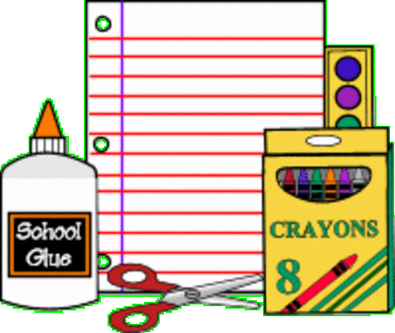

KINDERGARTEN: 2 boxes of tissues, 2 or more glue sticks, safety scissors (not plastic blades), 1 box of 8 large Crayola™ crayons, 1 box of 24 colors (not more than 24), pencils (at least 2), 1 box of washable Crayola™ markers, 1 bottle of Elmer’s™ School Glue, 2 wide-ruled spiral bound notebooks, 1 folder to take papers home, paint shirt (man’s short-sleeved shirt), school bag for taking items to and from school, headphones/ear buds

GRADES 1-2: 3 wide-ruled spiral bound notebooks, 3 folders, 1 packet of loose leaf paper, crayons, box of washable Classic Colors Crayola™ markers, 1 package of #2 pencils, 2 large glue sticks, large eraser, ruler (inch and cm, stiff-not flexible), scissors, school box with snap-on lid, 1 bottle Elmer’s School Glue, backpack/school bag, gym shoes, box of tissues, book cover (fits books up to 8” x 10”), headphones/ear buds

GRADES 3-4: #2 pencils, school glue, erasers, glue sticks, scissors, 4 notebooks, gym shoes, highlighter, 10 - 2 pocket folders, 2 boxes of tissues, school bag, ruler (inch and cm, stiff-not flexible), heavy duty 1” 3-ring binder, compass (4th Grade), 24 ct. crayons, colored pencils, markers, loose leaf paper, red pen, blue or black pen, headphones/ear buds, 4 new or used tennis balls, a large plastic milk crate (4th graders may choose to use their desk seat pack from the previous year.)

GRADES 5-6: 5 spiral-bound notebooks, protractor, highlighter, scissors, glue sticks, school glue, crayons, erasers, gym shoes, 2 folder, pens (red and blue/black), pencils (mechanical preferred), 12 inch ruler (inch & cm, stiff—not flexible), backpack or school bag, 2 boxes of tissues, loose leaf paper, 2 heavy duty 1" 3-ring binders, milk type crate, colored pencils, markers, headphones/ear buds, 4 new or used tennis balls

GRADES 7-8: loose leaf paper, eraser, pens (blue or black), sharp point scissors, 5 spiral-bound notebooks, markers, protractor, 12 inch ruler (inch & cm, stiff-not flexible), pencils, gym shoes, 3 pocket folders, crayons, glue or glue stick, colored pencils, 2 boxes of tissues, headphones/ear buds, basic calculator, 4 new or used tennis balls

*All hard cover textbooks must have protective covers.

Trinity Lutheran School
500 W. Church St.
Belle Plaine, MN 56011
952-873-6320
www.trinitybelleplaine.org

